February monthly report
……..........................................................
Dr. Pongkarn Chakthranont
Sothearoth Heng
NCR ID: 803198
Under the supervision of
Dr. Pongkarn Chakthranont
Contract Number: NCR-NN-2023-20170-EN
February 2024
Project Title:
Development of Cu-based catalyst for electrochemical CO₂ reduction to C₂ products: combined computational chemistry and electrochemical engineering approach

- Tasks list for February
- Optimization of the MEA system with a cell configuration of Ni/AEM/Ag_{100nm} at 200mA/cm²:
  - [KOH]: 0.5-1.5 M
  - Cathodic humidity: 30-70 C
  - CO₂ flow rate: 5-50 ml/min
- CO2RR test in Flow rate under the same operating MEA conditions to further confirm Formate byproduct.
- Synthesis of silver nanoparticles.
- Optimization of Ag ink (fixed mass loading of 0.5 mg/cm²):
  - Different dispersive solvents (EtOH, n-Hexane, and IPA)
  - Different binders (5%wt Nafion and 5%wt Sustainion XC-9)
  - Modulating 5%wt Sustainion XC-9 quantity (5-30%)

- Experimental Procedure
Synthesis of Ag NPs
Briefly, 1.91 g of AgNO₃ precursor was thoroughly dissolved in 150 ml of DI water to make 75mM AgNO₃ solution. NaBH₄ was used as a reducing agent. 0.47 g of NaBH₄ was carefully dissolved in 150 ml of cold DI water under 0°C ice bath and stirring rate of 500 rpm. Afterwards, the AgNO₃ solution was slowly dropped into NaBH₄ with a flow rate of 1 ml/min, and then a transparent solution turned into black color, indicating the formation of Ag NPs. After completely adding AgNO₃ solution, the mixture solution was further stirred at 500rpm for another hour to complete the reaction. The precipitated Ag product was filtrated and washed by DI and EtOH for several time and followed by drying under 60°C for 6h. The obtained Ag NPs was further characterized.

Preparation of Ag cathode electrode
The as-prepared AgNPs catalyst was spray-coated onto Sigracet 36BB carbon paper. 100 mg of the as-prepared AgNPs and different binders (10% of 5 wt% of Nafion and 5 wt% Sustainion XC-9) were ultrasonically mixed with IPA for 30 min to form a colloidal solution which then was sprayed onto carbon paper with 0.5 ml/min at 95 °C to obtain ~ 0.5 ± 0.1 mg/cm².

Electrochemical CO2RR measurements
A 5 cm² MEA electrolyzer was used to evaluate the CO2RR performance under modulated operating conditios. The Ni foam, AEM (X37-50 Grade RT, Dioxide Materials), and sputtered Ag_{100nm}/AgNPs were employed as the anode, membrane, and cathode electrode, respectively. 50 ml of 0.5, 1.0, and 1.5 M KOH was recirculated and used throughout the experiment as the anolyte at 10 ml/min. Humidified CO₂ gas (50 °C) was fed at the cathodic inlet stream with a flow rate of 5, 15, 30, 40, and 50 ml/min. The cathodic outlet was directly injected into an online gas-chromatography for further gas products analysis.

- Result
    - Optimization of the MEA system
Influence of KOH anolyte concentration on eCO2RR performance
The effect of KOH anolyte concentration on overall cell performance was studied, as depicted in Fig. 1. The FE of H₂ was independently impacted by KOH concentration, while CO selectivity of the MEA system was substantially declined upon raising KOH concentration. A significant decrease in FE of CO from 76% to 55% was observed when increasing KOH concentration from 0.5 to 1.5M under 200 mA/cm². Furthermore, the salt precipitation at the cathodic GDL was also noticed, especially under a high concentration of KOH. This could be attributed to a high electro-osmotic crossover of K+ ions from the anolyte compartment to the other side through AEM membrane that facilitate the formation of both K₂CO₃ and KHCO₃ on the cathodic GDL and macro-porous layer (MPL).^{1,2} The K+ crossover unfavorably influences cell selectivity, eCO2RR performance, and long-term stability. Therefore, 0.5M KOH concentration will be selected for further investigation to minimize the salt formation and enhance overall MEA electrolyzer cell performance.
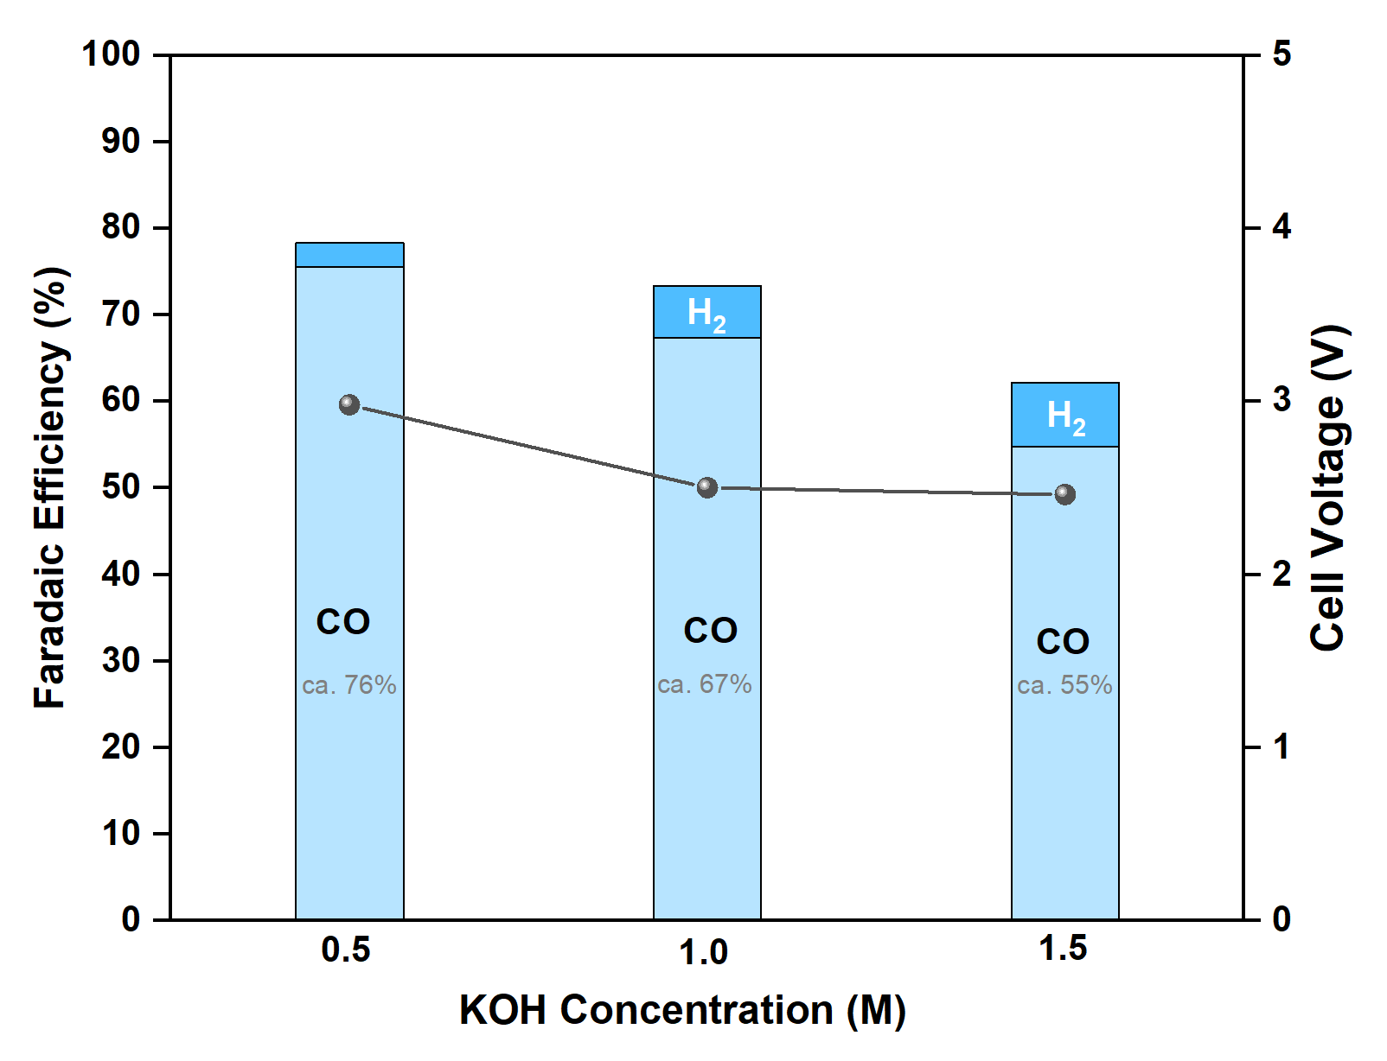
Figure 1. Faradaic efficiency of the MEA electrolyzer under 200 mA/cm² and varied KOH concentrations.

Influence of cathodic humidity on eCO2RR performance
Fundamentally, the electrochemical reduction of CO₂ requires proton (H+) to drive the reaction, and the H+ source mainly comes from the cathodic humidity. In Fig. 2, the humidity content of the cathodic CO₂ gas stream was modulated by varying the bubbler temperature. At a current density (j) of 200mA/cm², the eCO2RR performance was slightly impacted by the humidity content which could be attributed to sufficient quantity of H+ required for CO2RR. However, at 250 mA/cm², the CO selectivity marginally increased upon raising the humidity content. These results elucidated the matter of humidity content at higher applied current density. Our observation shows a similar trend to Pellumbi et al. 2023 that higher water/humidity level is required as increasing applied current density.³
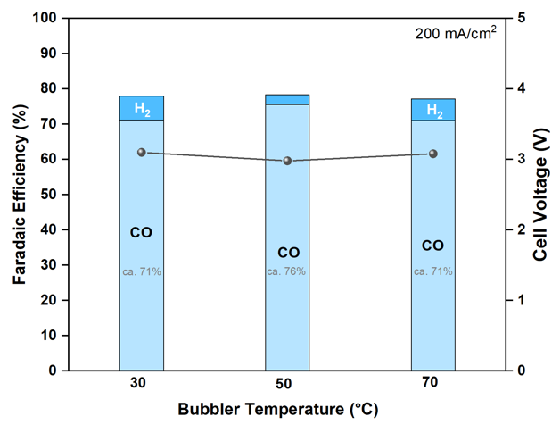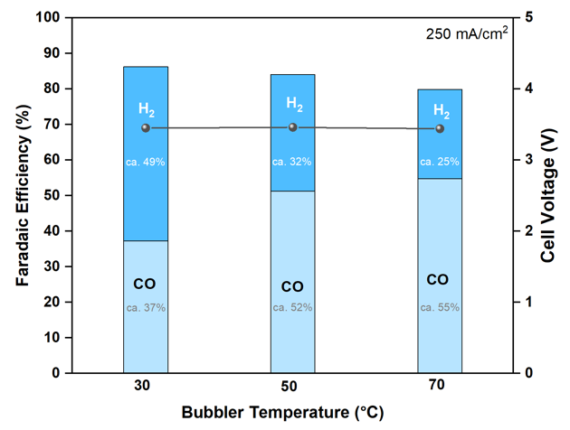
Figure 2. Faradaic efficiency of MEA electrolyzer under j of 200-250 mA/cm⁻² and different bubbler temperatures (30, 50, and 70°C).

Influence of the absolute amount of CO₂ supply
To further address the factor determining the eCO2RR performance, the influence of cathodic CO₂ gas flow rate was conducted. As can be seen in Fig. 3, the CO2RR was performed under applied current of 200 mA/cm² and various CO₂ flow rate of 5, 15, 30, 40, and 50 ml/min. At such a low CO₂ supply of 5 ml/min, a competing HER reaction was predominated over the CO2RR, likely due to a CO₂ deficiency at the cathode surface, resulting in low FE(CO). However, the CO selectivity of the AgNPs cathode was significantly inclined after gradually increasing the CO₂ flow rate. The maximum FE(CO) was approximately 76% at the CO₂ flow rate of 30 ml/min, while further increasing the CO2 flow rate to 50 ml/min indicated a slightly drop of FE(CO) and rise of FE(H₂). Despite the formation of H₂ byproduct at a higher CO₂ flow rate, the overall faradaic efficiency (FE_{total}) under conditions of higher CO₂ supply approached 100%, surpassing that of lower CO₂ supply conditions. These results revealed that another unwanted HCOO- byproduct can be suppressed by raising the CO2 supply. Therefore, further investigation of the eCO2RR at higher CO2 flow rates (100-200 ml/min) should be taken into account to minimize the formation of HCOO- byproduct and narrow the FE_{total} gap.
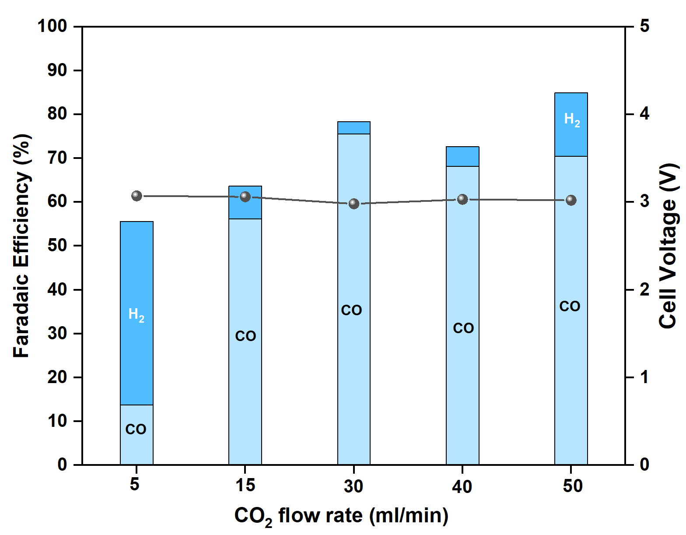
Figure 3. Faradaic efficiency of the MEA under 200mA/cm² and varied CO₂ flow rate (50°C).

    - Optimization of the Ag cathode ink
eCO2RR performance test in flow cell electrolyzer
In order to further confirm the total faradaic efficiency loss (ca. 15-20%) in which we hypothetically considered the formation of HCOO- (Formate) byproduct along with H₂, the electrochemical reduction of CO₂ was performed in a flow cell electrolyzer under the same MEA conditions at 200 mA/cm². As can be seen, 13% of HCOO- byproduct was observed in the catholyte along with 81% of CO and 11% of H₂, thereby proving that there was another side reaction occurred during CO2RR and another approximately 15% loss of FE could be a HCOO- byproduct. This results also aligned with other research groups reporting the formation of HCOO- on the Ag cathode catalyst under higher applied current density.^{1,4–6}
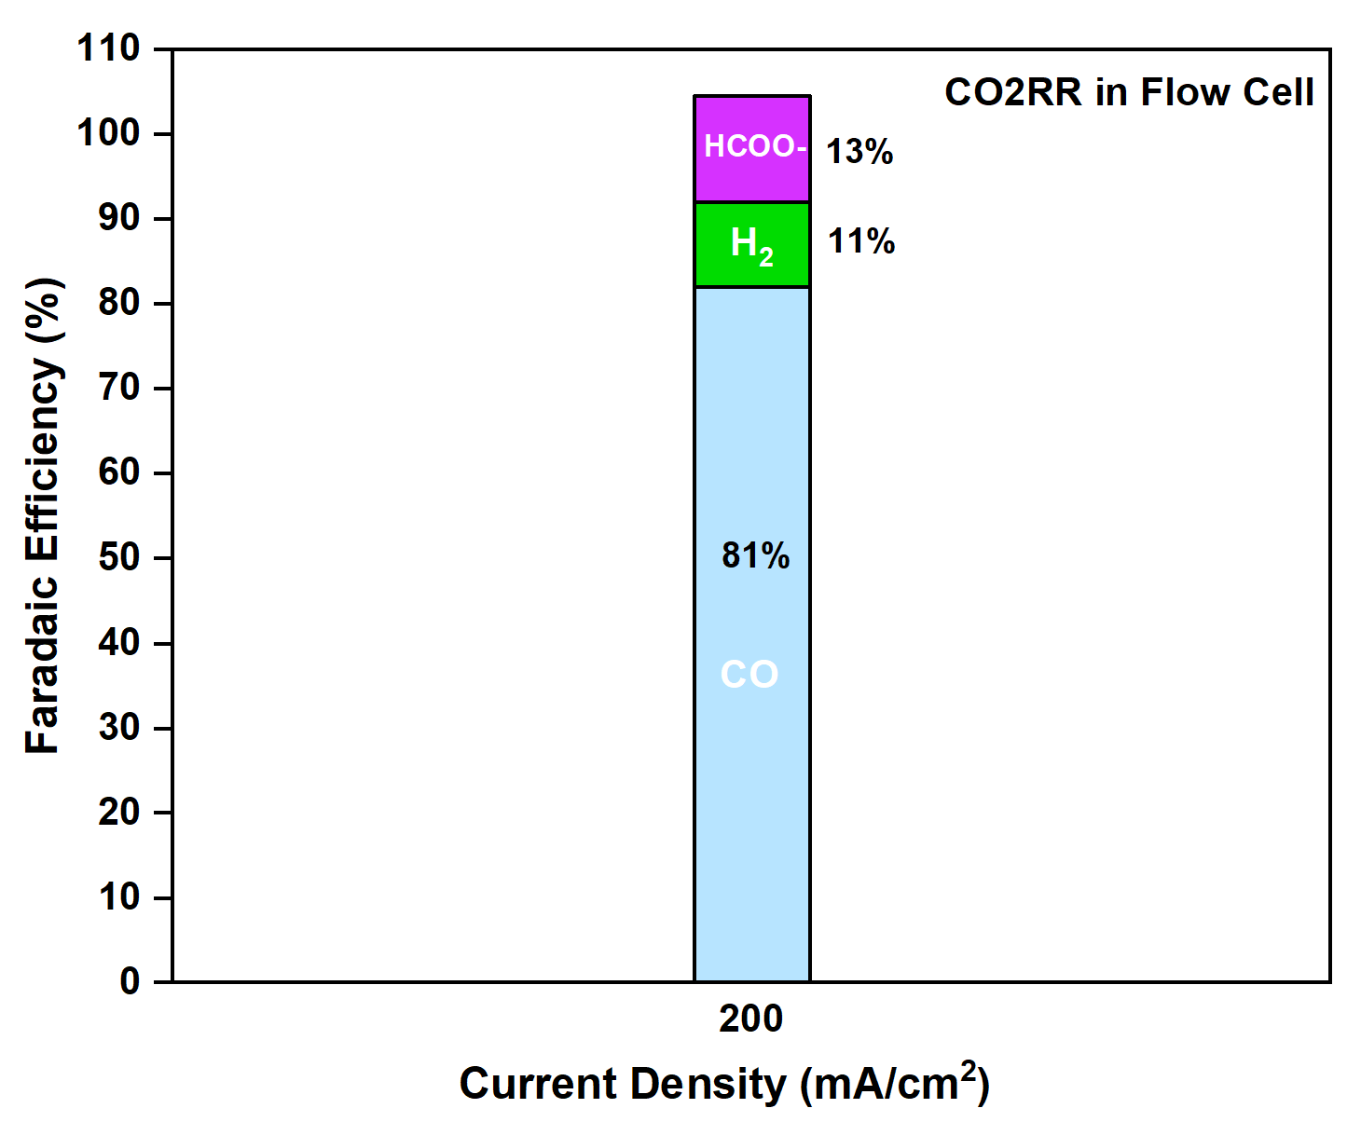
Figure 4. CO2RR performance in a flow cell electrolyzer at 200 mA/cm²

Influence of different binders on eCO2RR performance of MEA cell
The type of binder used in the cathode ink preparation strongly affects the overall cell performance. As can be seen in Fig. 5, AgNPs cathode ink mixed with 10% of 5%wt Sustanion XC-9 binder was highly CO selective than the ink mixed with 10% of 5%wt Nafion. Therefore, the Sustainion XC-9 binder will be selected as a binder for AgNPs cathode ink preparation.
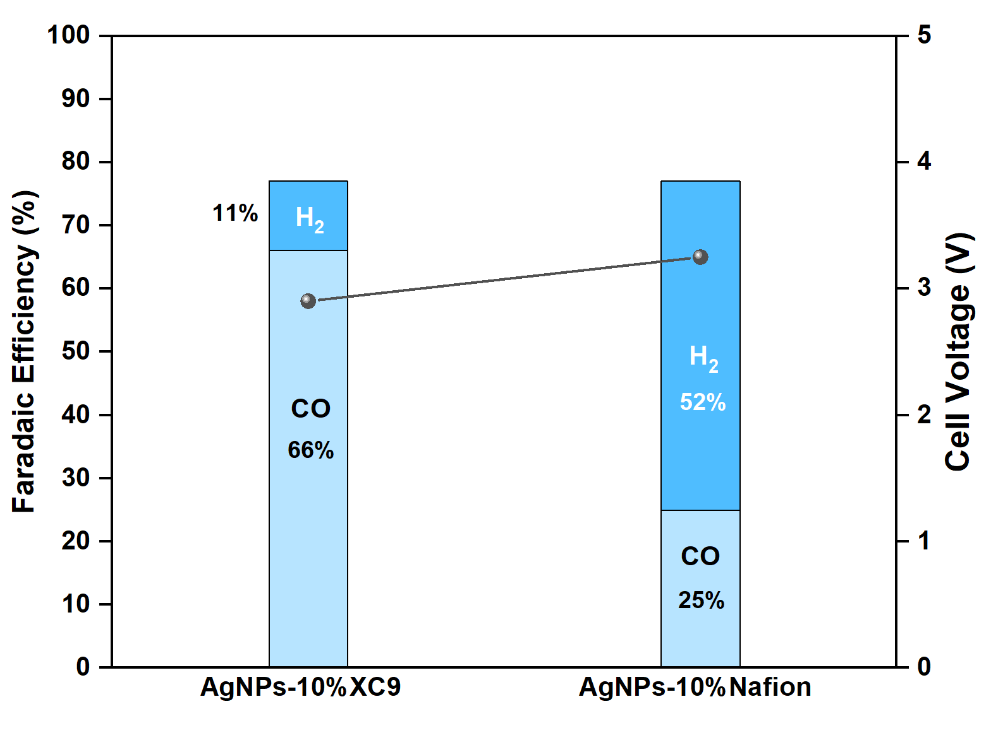
Figure 5. CO2RR performance of AgNPs cathode with different binders at 200mA/cm².

Influence of different binders on eCO2RR performance of MEA cell
The effect of Sustainion XC-9 binder quantity on over all CO2RR performance of the cell was conducted to further optimize the amount of XC-9 binder used in the ink preparation. As shown in Fig. 6, the amount of XC-9 binder was modulated from 5 to 30%. At the lowest quantity of XC-9 (5%), the competing reaction of HER tends to be much higher than CO2RR which results in low CO selectivity. This might be attributed to poor Ag dispersion and Ag agglomeration that could reduce the Ag active sites. On the other hand, the CO selectivity of the cell drastically increased after raising the amount of binder from 5% to higher. FE(CO) of 66% was achieved at 10% XC-9 with FE(H₂) of 11%. However, we observed that further increasing the amount of binder from 10% to 20 and 30%, the CO selectivity tends to be lowered along with high HER. This could be resulted from the ionomer-enriched surface of the cathode electrode at higher XC-9 binder, thus leading to diminish the Ag active sites. Therefore, 10% of 5%wt Sustainion XC-9 binder will further be used for future cathode ink preparation.
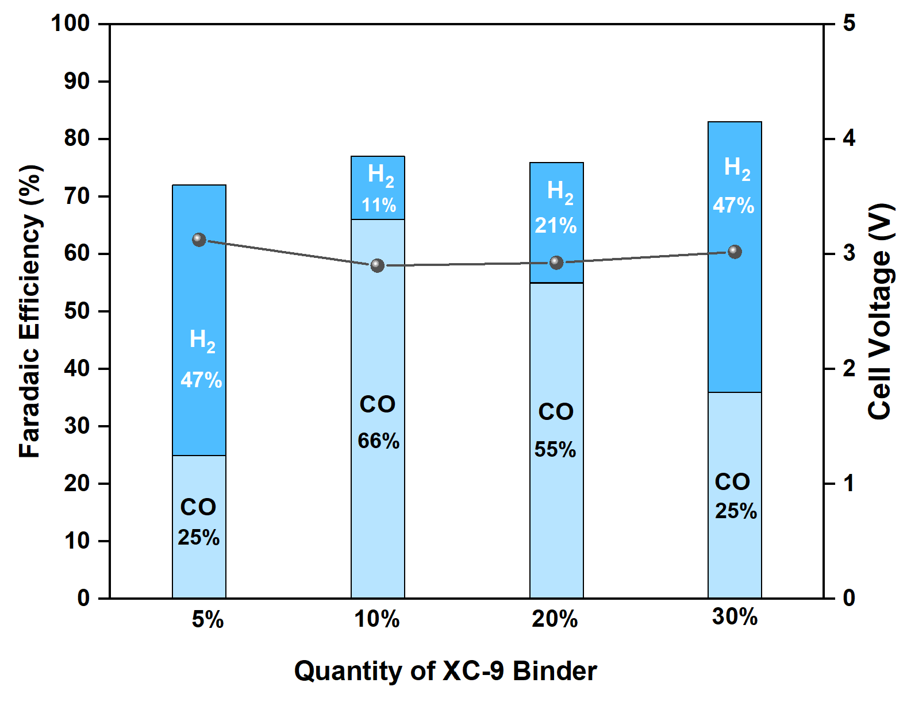
Figure 6. CO2RR performance of AgNPs cathode with modulated Sustainion XC-9 quantity at 200 mA/cm².

Reproducibility of the synthesis of Ag nanoparticles
According to Fig. 7, the Ag particle size of 4 different batches was approximately 100-200 nm. However, we observed a poor size distribution of Ag nanoparticles in batch 2 and 4 in which smaller Ag nanoparticles were covered onto larger Ag particles. Further investigation is needed to reproductively synthesize the AgNPs with the same particle size and particle size distribution.

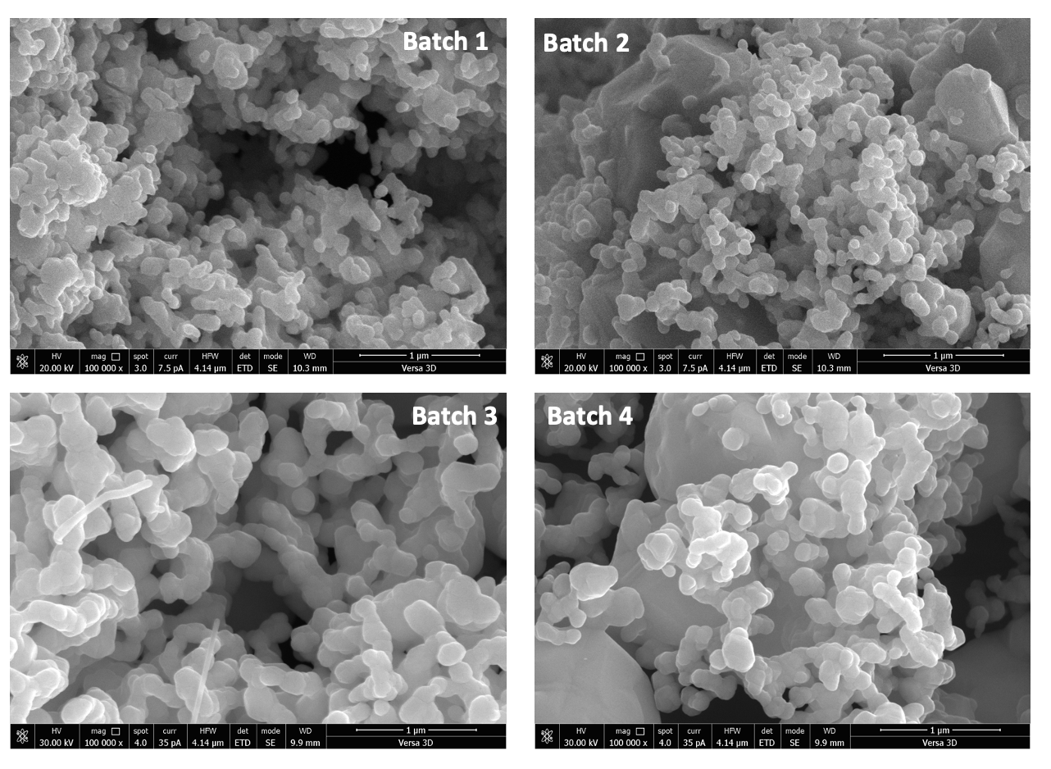
Figure 7. SEM images of different batches of as-prepared AgNPs.

- Summary
In brief, we conducted optimization of both the MEA system and Ag cathode ink. Through modulating various parameters within the MEA electrolyzer, including the concentration of KOH, humidity levels, and CO2 flow rates, we identified the optimal conditions for CO2RR performance at an applied current density of 200 mA/cm2. Additionally, testing the CO2RR performance in a flow cell electrolyzer confirmed the presence of an undesired HCOO- byproduct at a rate of 13% under 200 mA/cm2. The optimization of the Ag cathode ink revealed several key findings: AgNPs exhibited superior dispersion in IPA solvent compared to EtOH and n-hexane, the Sustainion XC-9 binder showed better CO selectivity compared to Nafion binder, and a mixture containing 10% of 5%wt Sustainion XC-9 achieved the highest FE(CO). Moreover, the AgNPs synthesized across four different batches displayed a particle size ranging from 100 to 200 nm, with batch 2 and batch 4 exhibiting poor particle size distribution.

- Upcoming tasks
- Investigation of CO2RR under higher CO2 flow rate (100-200ml/min) using AgNPs and sputtered Ag cathodes
- Investigation of CO2RR under different CO₂ partial pressures using 0.5mg/cm² AgNPs cathode
- Synthesis of AgNPs
- Testing CO2RR performance of Co/Zn/Ni-SACs cathode catalysts

- References
1. Yang, K. et al. Cation-driven increases of co2utilization in a bipolar membrane electrode assembly for co2electrolysis. ACS Energy Lett 6, 4291–4298 (2021).
2. Joensen, B. Ó. et al. Unveiling Transport Mechanisms of Cesium and Water in Operando Zero-Gap CO 2 Electrolyzers. doi:10.26434/chemrxiv-2023-g39tj.
3. Pellumbi, K. et al. Pushing the Ag-loading of CO2 electrolyzers to the minimum via molecularly tuned environments. Cell Rep Phys Sci 4, 101746 (2023).
4. Wu, Y. et al. Mitigating Electrolyte Flooding for Electrochemical CO2Reduction via Infiltration of Hydrophobic Particles in a Gas Diffusion Layer. ACS Energy Lett 7, 2884–2892 (2022).
5. Larrazábal, G. O. et al. Analysis of Mass Flows and Membrane Cross-over in CO2 Reduction at High Current Densities in an MEA-Type Electrolyzer. ACS Appl Mater Interfaces 11, 41281–41288 (2019).
6. Subramanian, S. et al. Geometric Catalyst Utilization in Zero-Gap CO2 Electrolyzers. ACS Energy Lett 8, 222–229 (2023).

